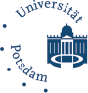
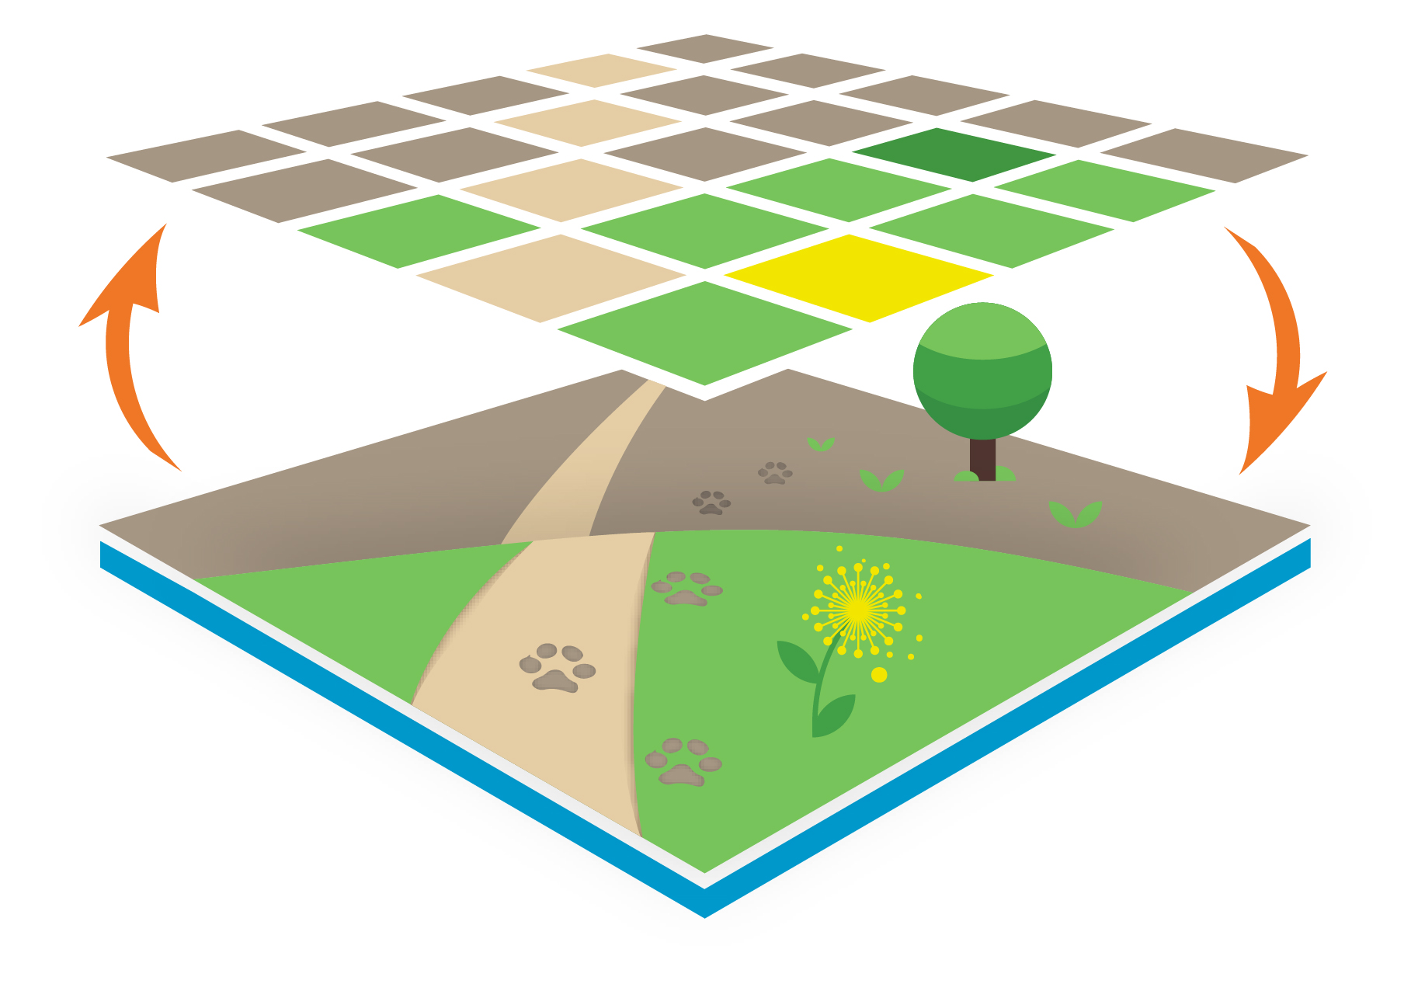
University of Potsdam
Plant Ecology and Nature Conservation

Institute for Biochemistry and Biology

Am Mühlenberg 3, 14476 Potsdam-Golm

Attention: new location from mid November onwards, details will follow!

Group seminar winter semester 2023 / 24
Mondays, 14:15 – 15:45 Preferably in person (exeptionally hybrid format)
Date | Speaker | Affiliation | Preliminary Title or Topic | Comment
16.10.23 | Kristin Scharnweber | PENC | Effects of mining activities on fish communities and food web dynamics in a lowland river
23.10.23 | All |  | Short presentations
30.10.23 | Bridging Day (before public holiday)
6.11.23 | Prof. Dr. Julia Fischer | University of Göttingen | TBA | Ecological Colloquium (AG Eccard)
13.11.23 | Cara Gallagher | PENC | TBA
20.11.23 | Franziska Eichhorn-Lüneburg | ZALF | Floristic diversity of former manor parks in Brandenburg
27.11.23 | Paul Berry | PENC | Activity and behavioural responses of African antelope to heat extremes | Hybrid
4.12.23 | Dr. Peter Scogings | University of KwaZulu-Natal | TBA | Ecological Colloquium (AG Linstädter)
11.12.23 | Dorothea Meneses / Nina Pellny | PENC | Theses on Armeria | Msc
18.12.23 | Tobias Kollmorgen / Jonas Hurtig | PENC | TBA / Plant-pollinator interactions along gradients of land-use intensity with camera traps | Msc
Christmas Holidays
8.01.24 | ??? |  |  | Ecological Colloquium
15.01. | Jonas Roth | PENC | TBA
22.01.24 | Benito Schoepke | ZALF | Plant species response at the interface of crop fields & protected grasslands – impact of farm practices
29.01.24 | Victoria Culshaw | TUM | TBA
5.02.24 | Tim Herkenrath | PENC | TBA

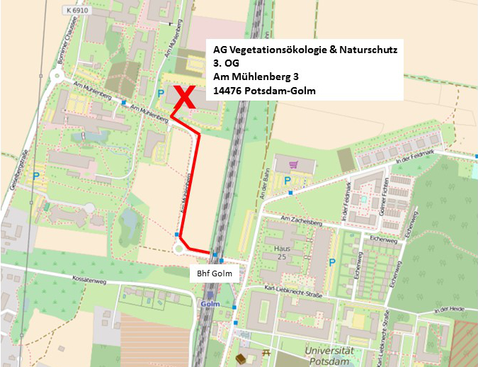
Buses: 605, 606
Trains: RB20/21

